Laboratory 06: 555 Timer and PWM
(Edit this document as needed)

Partner 1: Saaif Ahmed

Partner 2: John Gonzalez

Part A
Brief description of 555 Timer experiment:

Building a 555 Timer Multivibrator circuit and analyzing voltage trends as well as the time periods for the LED being on and off to calculate the total period with considerations to the average voltage and capacitor behavior.

Copy of 555 Timer circuit from LTSpice.

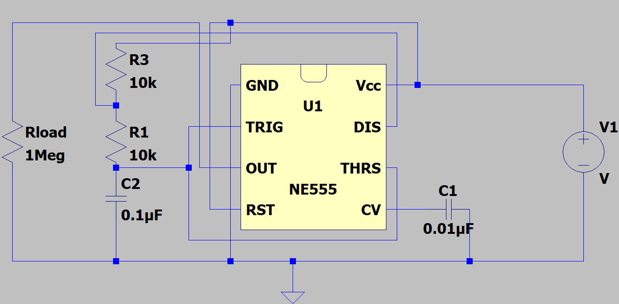

Voltage plots of the threshold/trigger (THRS/TRIG), discharge (DIS), and output (OUT).

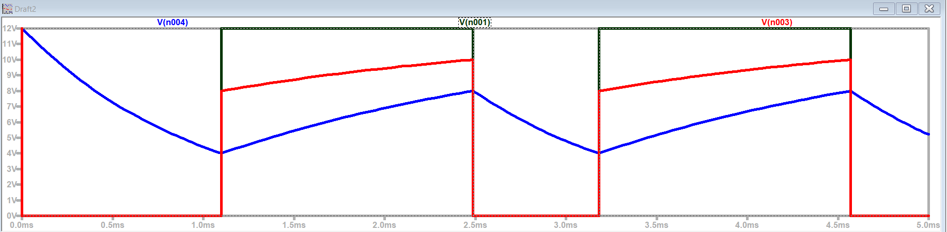

-Black line is output voltage. Overlapping blue lines are threshold and trigger. Red is DIS

ON/OFF durations of the timer output.

 | Calculated | Measured
Time ON | 1.386ms | 1.382ms
Time OFF | .693ms | 0.695ms

Total period

Period | 2.08ms

Which plot corresponds to the charging/discharging of the capacitor (THRS/TRIG, DIS or OUT)?

The charging and discharging of the capacitor is the THRS/TRIG plot (blue line).
Maximum and minimum capacitor voltages

V_{Cmax} | 8V
V_{Cmin} | 4V

Is the rate of change for capacitor charging and discharging the same?
*****The rate of change for the capacitor charging and discharging are slightly similar though because it is not an ideal circuit there is a slight difference.

Average output voltage

Vave | 6V

Verification of plots with annotations: TA/Instructor’s initials __________HC________
Determine an expression for the duty cycle using the given expression for Time_{on} and Time_{off}. Recall, duty cycle is 100% × (time high)/(Period).

100%*(Time_on/(Time_on+Time_off)) = Duty Cycle

What relative values for R1 and R2 produce the largest duty cyle?

0 ohms for R2 and any value for R1, since (R1+R2)/(R1+2R2) reduces to R1/R1 or 1 when R2 is equal to 0.

What relative values for R1 and R2 produce the smallest duty cyle?

If R1 is 0 and R2 is some arbitrary value for resistance, the lowest duty cyle possible would have to be 50% since the formula would reduce to R2/2*R2

Given a 3kΩ, a 10kΩ, and a 30kΩ, what combination of R1 and R2 will produce the largest average voltage (LTSpice)?

R2 = 3k ohms, R1 = 30k ohms

Include a plot from LTSpice for the above choice, noting the average voltage.

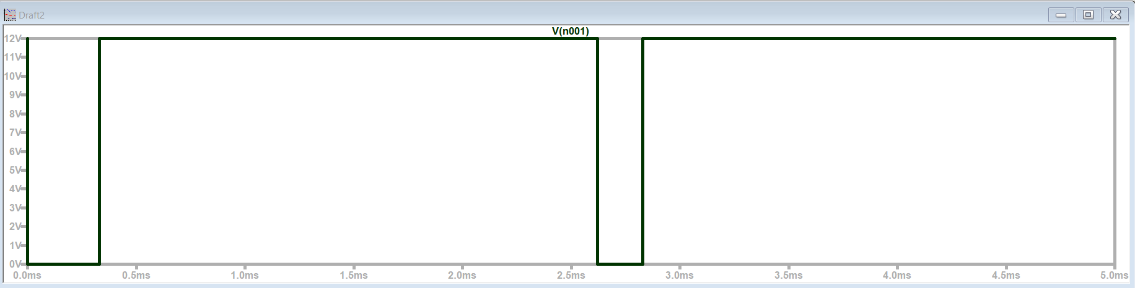
Average Voltage would be approximately 11V

Verify that the time high and the time low are consistent with the calculated results.
Time High =2.2ms Consistent with calculated
Time Low=0.2ms Consitent with calculated

Given a 3kΩ, a 10kΩ, and a 30kΩ, what combination of R1 and R2 will produce the smallest average voltage?

R1 = 3k Ohms, R2 = 30k Ohms

Include a plot from LTSpice for the above choice, noting the average voltage.

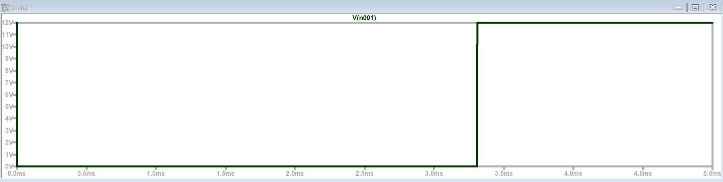

Average is approximately 6.28V

Verify that the time high and the time low are consistent with the calculated results.
Time High = 2.2 ms – Consistent with calculated results
Time Low =2.0ms – Consistent with calculated

Analog discovery plot of your output voltage for the schematic in Figure A-6, annotating the plot as detailed in the experiment.
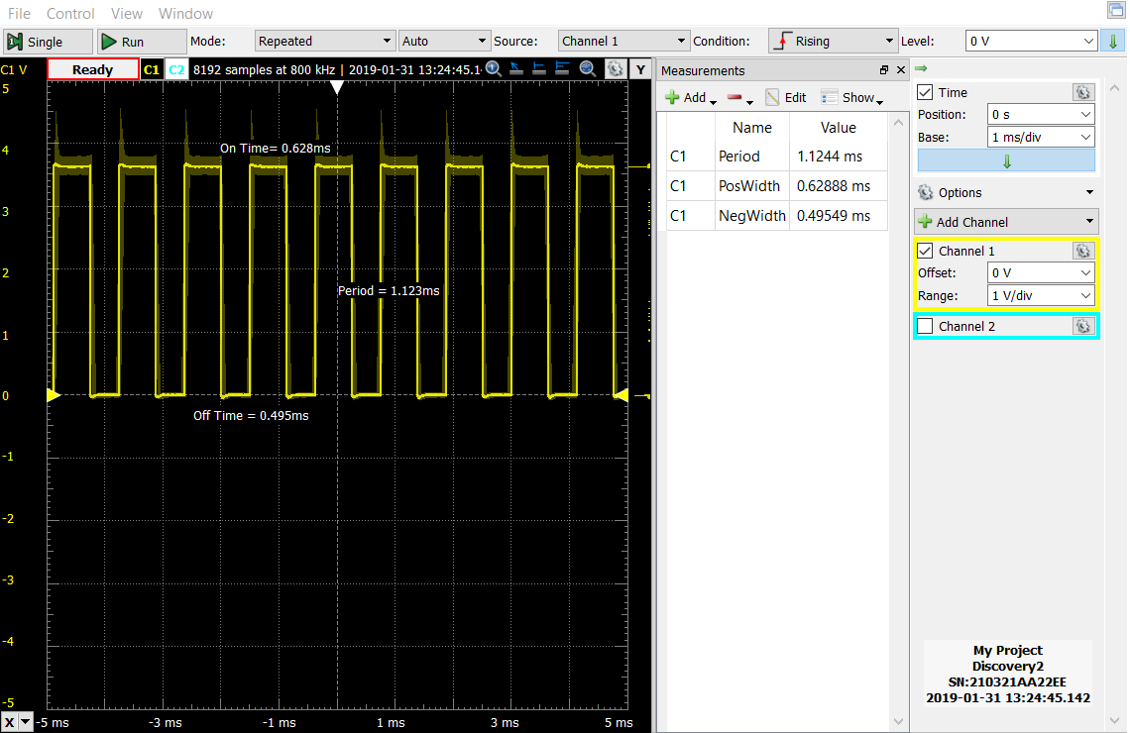

 | Calculated | Measured
Time ON | 0.6237ms | 0.628ms
Time OFF | 0.47124ms | 0.495ms
Period | 1.094ms | 1.12ms

How do the calculated and measured times compare?
The calculated times are less than the measured times but they are very close and within a reasonable error.

Keeping the same resistors, calculate a capacitance value that makes the total period approximately one second.

Capacitance | 91uF

Is it blinking at approximately one second intervals?

Yes

ON/OFF durations of the timer output.

Time ON | 634ms
Time OFF | 493ms

What relationship do these values have with the original circuit, before you changed the capacitor?

They vary by a factor of approximately 1000. Both the time on and off are now 1000 times larger.

Verification of circuit/results: TA/Instructor’s initials _______HC___________

Part B
Brief description of PWM experiment:
In order to analyze the effects of PWM, we set up a circuit that based on the “clock” signal will turn an LED on and off. We will also adjust frequency in order to observe how that changes the LED’s tendency to turn on or off.

Analog Discovery plot of the input voltage.

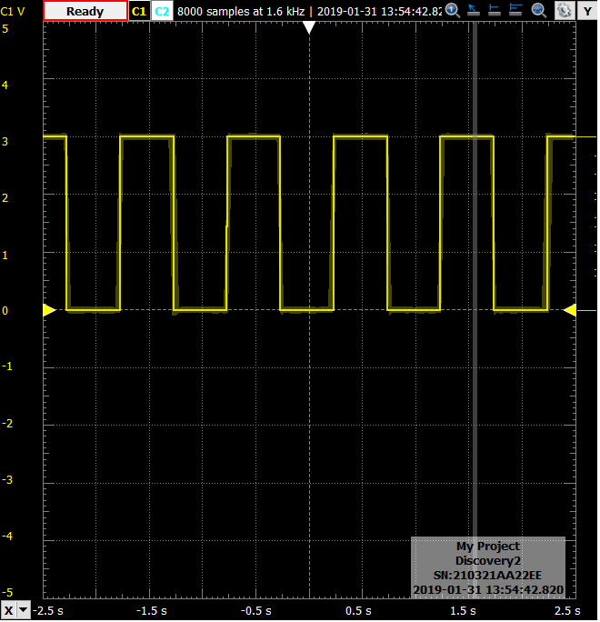
Description of LED observations with a 0V-3V square wave.

The LED will turn on for 1 second and turn off for another 1 second.

Description of the LED when varying the duty cycle for 1s (1 Hz) periods

The time the LED stays on gets longer as the duty cycle approaches 100%, and the time off increases as it approaches 0%.

Description of the LED when varying the duty cycle for 0.05s (200 Hz) periods.

The brightness of the LED appears to increase as the duty cycle increases.

Average voltage measurement when incrementing the duty cycle.

Duty Cycle | Average Voltage
10% | .295 V
20% | .596 V
30% | .896 V
40% | 1.197V
50% | 1.497 V
60% | 1.798 V
70% | 2.098 V
80% | 2.398 V
90% | 2.699 V
100% | 3.000 V

Verification of circuit/results: TA/Instructor’s initials ____________YL__________

Highest frequency you can still see the LED blinking when looking directly at the LED.

Frequency | 28 Hz

Highest frequency you can still see the LED blinking with your peripheral vision.

Frequency | 11 Hz

What is the refresh rate of video displays (Google can help)?

Frequency | 60-240 Hz

Is your eye taking ‘pictures’ faster than the refresh video refresh rate?

No

